CS 255 System Design Document Template

This template lays out all the different sections that you need to complete for Project Two. Each section has guidance to prompt your thinking. You will need to continually reference the interview transcript as you work to make sure that you are addressing your client’s needs. There is no required length for the final document. Instead the goal is to complete each section based on what your client’s needs are. Remove this note when you are finished, and replace all bracketed text with the relevant information.

UML Diagrams

UML Use Case Diagram
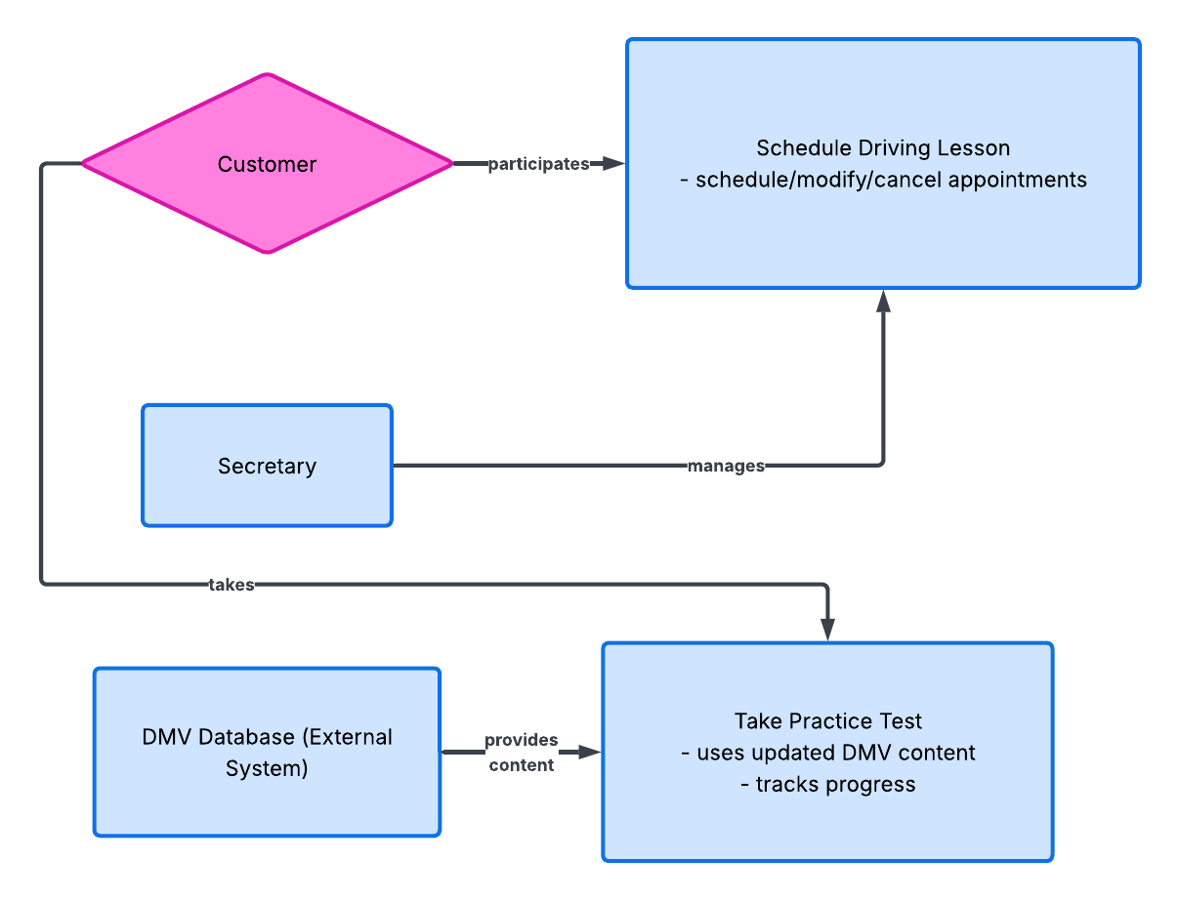

UML Activity Diagrams
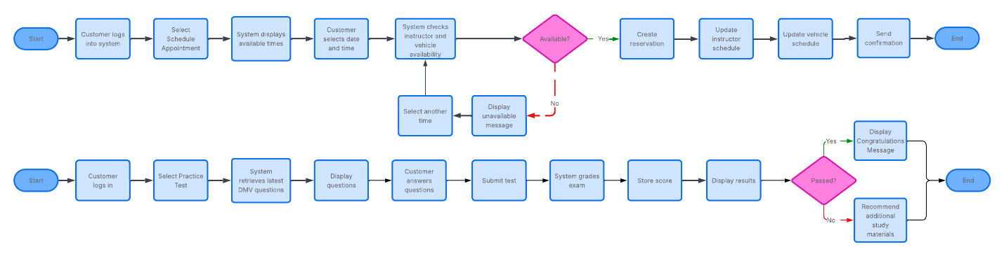

UML Sequence Diagram
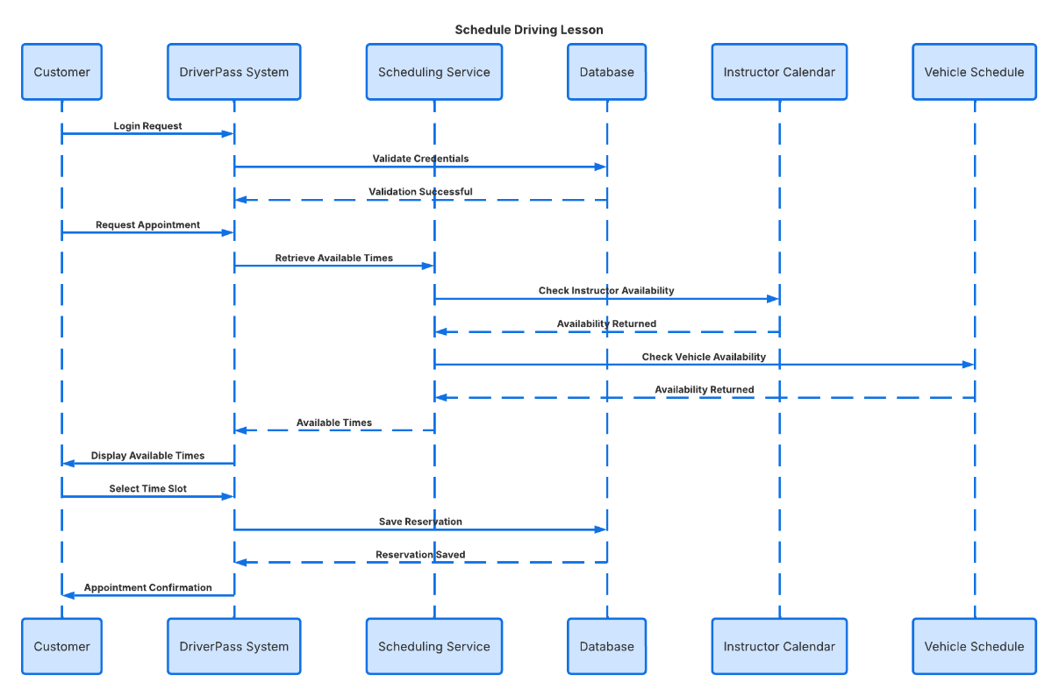

UML Class Diagram
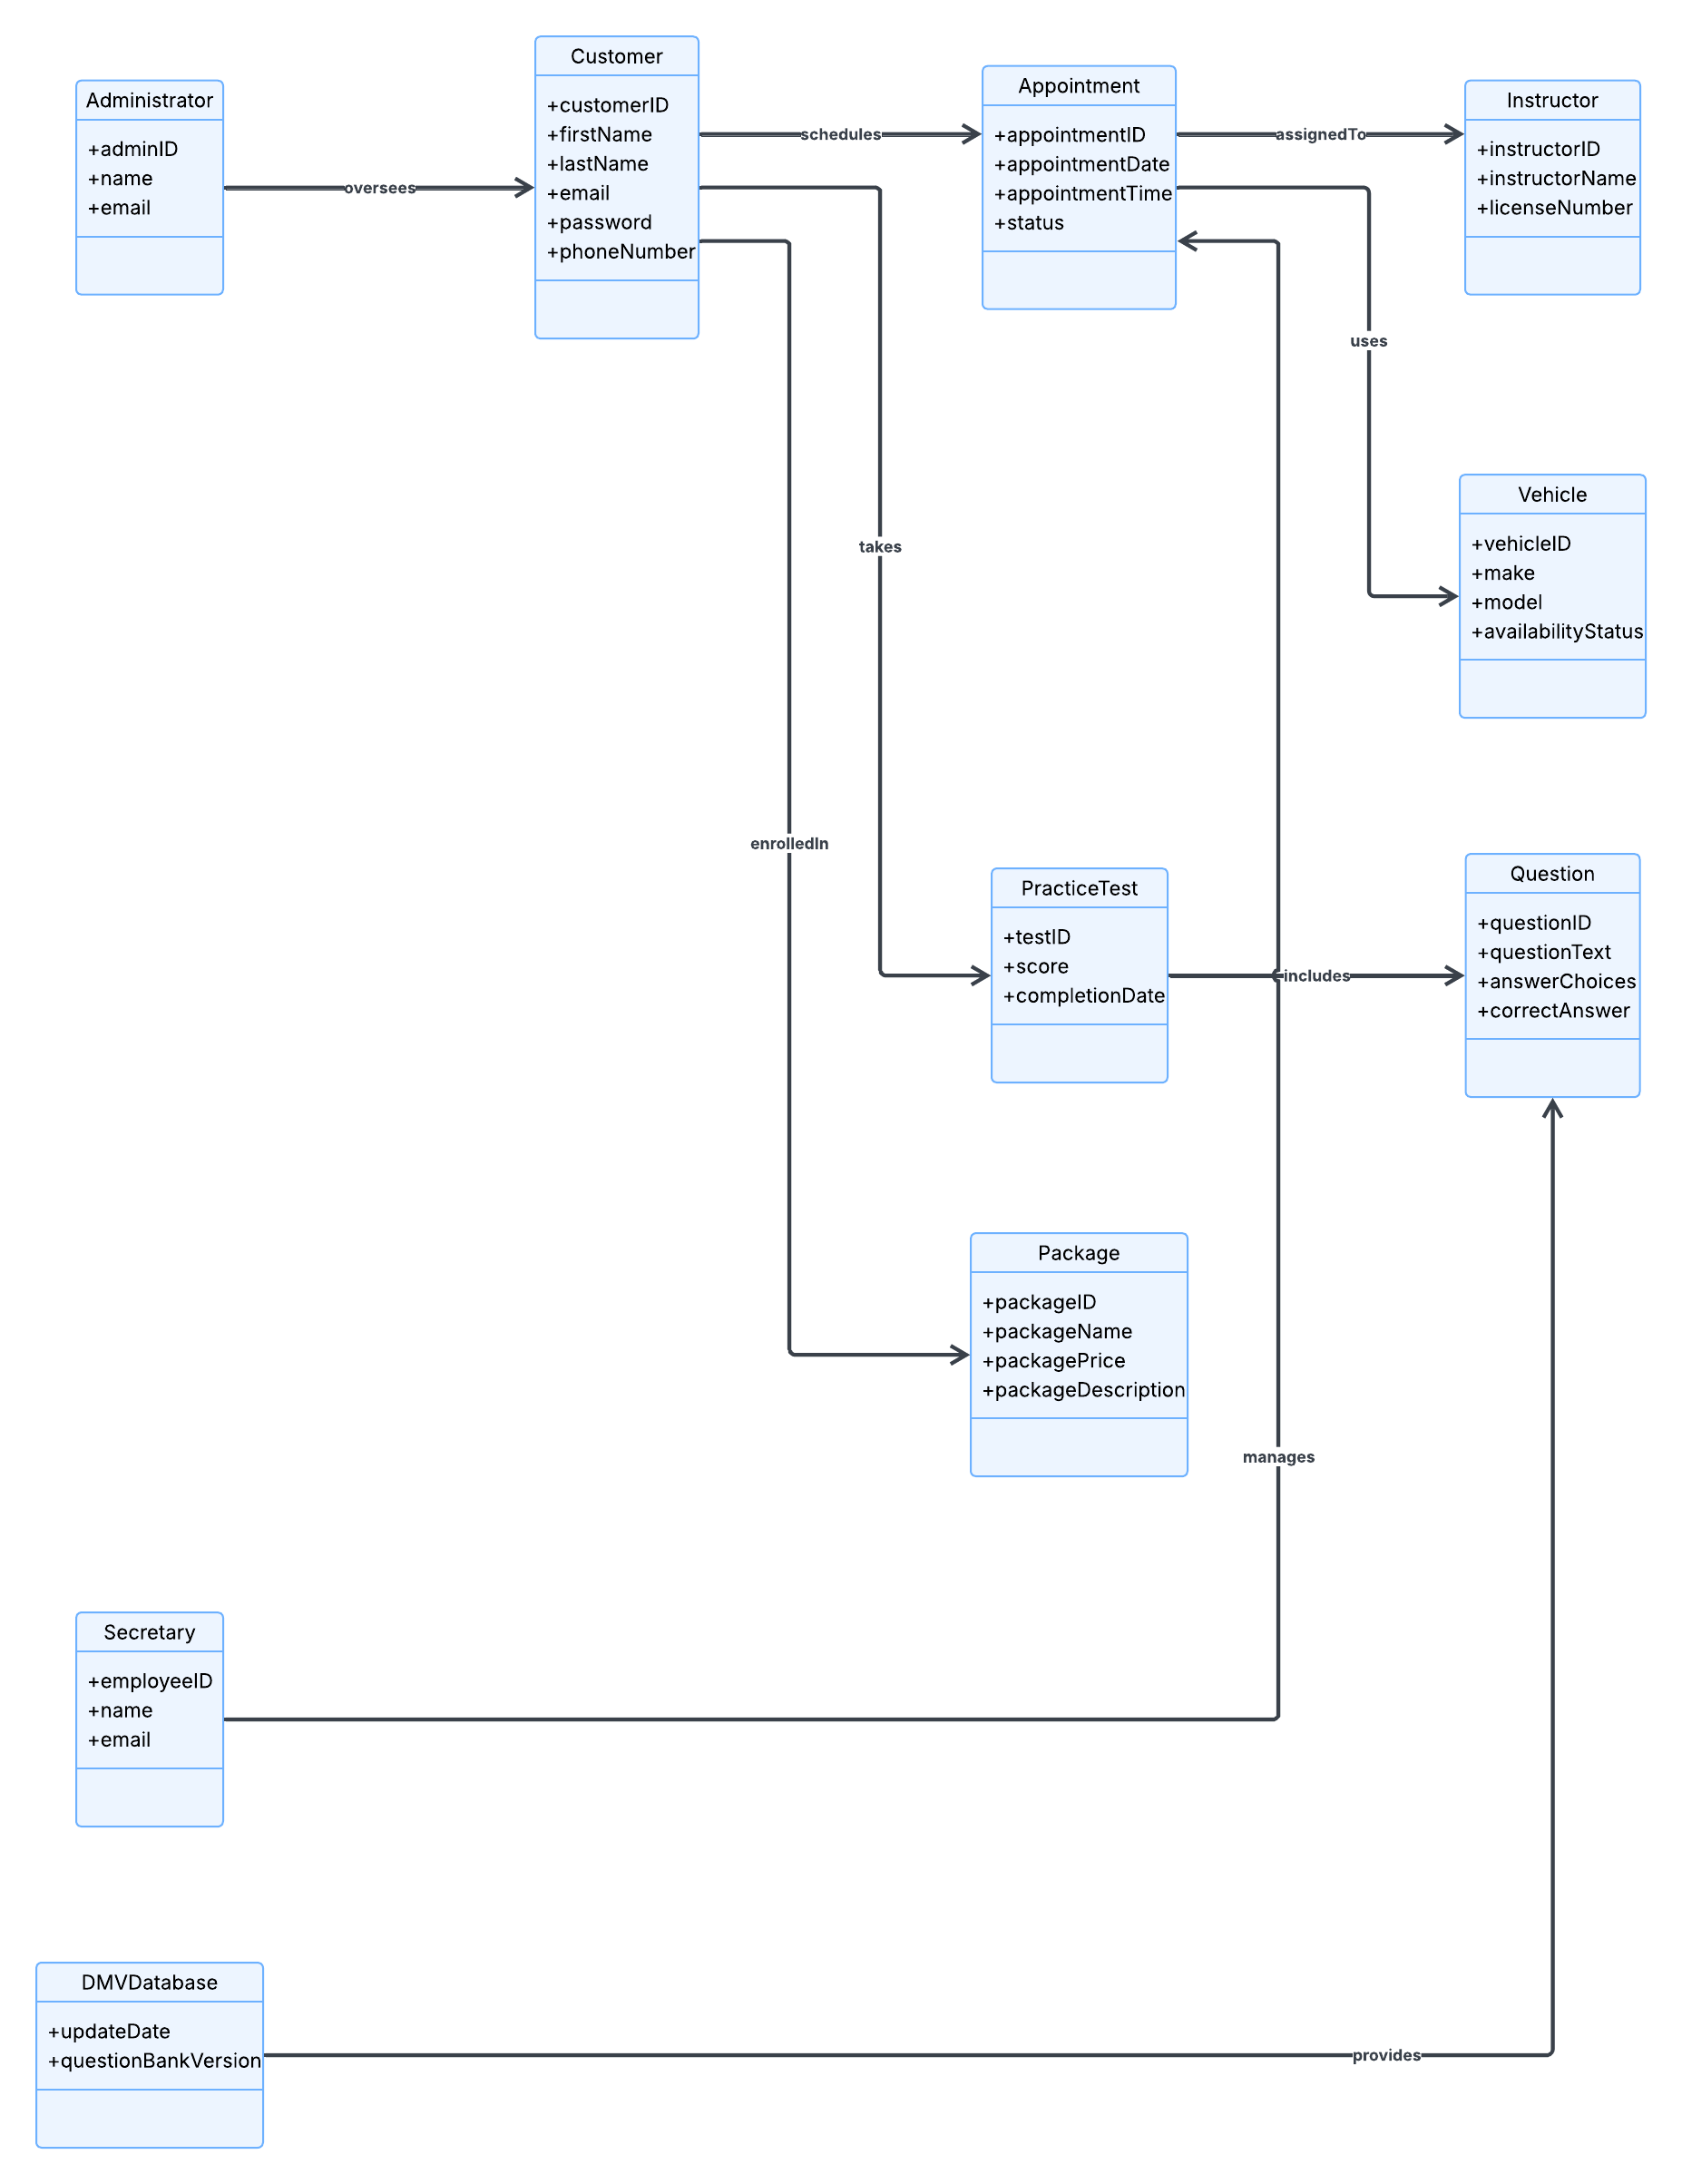

Technical Requirements
Technical Requirements
The DriverPass system will be a secure cloud-based web application enabling customers to purchase training packages, schedule driving lessons, access online learning materials, and complete Department of Motor Vehicles (DMV) practice tests. It will support multiple user roles, including customers, secretaries, administrators, instructors, and management staff.

Hardware Requirements
A cloud-hosted web server that supports concurrent users and provides secure storage is required. Customers may use desktops, laptops, tablets, or smartphones with internet access. Employees require workstations with updated web browsers.

Software Requirements
The system will operate through web browsers, including Chrome, Edge, Firefox, and Safari. A relational database will store customer data, appointments, packages, schedules, vehicle assignments, and test results. Integration with DMV sources will keep practice questions up to date.

Infrastructure Requirements
The application will use cloud services for availability, scalability, and backups. Secure HTTPS will protect all transmitted data. Automated backups will ensure data recovery in the event of a system failure.

Security Requirements
Users must authenticate with unique usernames and passwords, which will be encrypted in the database. Role-based controls restrict access to appropriate functions. Failed logins will be monitored, and temporary account locks will be imposed after repeated failures. Authorized users can securely recover passwords.

Performance Requirements
The system should respond in under three seconds for actions such as logging in, scheduling, viewing lessons, and accessing tests. It must support multiple users simultaneously without noticeable performance decline.

Maintenance and Adaptability Requirements
Admins can add, modify, disable, or remove user accounts without coding changes. DMV test content must be updateable with admin tools. The system should support enhancements, browser, and platform changes with minimal interruption.

